

**Ahsanullah University of Science & Technology**

**Department of Computer Science & Engineering**

**Course No. :** CSE 4108

**Course Name :** Artificial Intelligence Lab

**Assignment No. :** 03

**Submitted To :**

Md. Siam Ansary Tonmoy Hossain

Department of CSE, AUST Department of CSE, AUST

**Submitted By:**

Name : Sanjida Akter Ishita

ID No. : 170204089

Session : Fall 2020

Section : B

Lab group : B2

**Date of Submission:** August 18, 2021

**QUESTION 01:** Define a recursive procedure in Python and in Prolog to find the sum of 1st n terms of an equal-interval series given the 1st term and the interval.

**ANSWER:**

**Code in Prolog:**

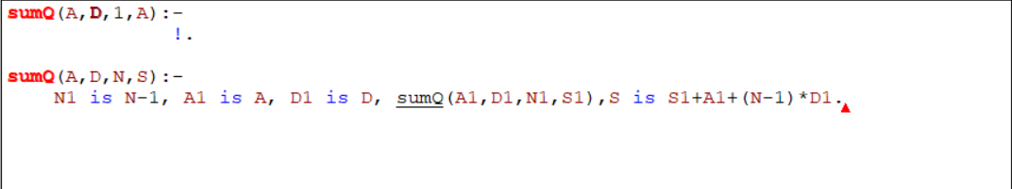

**Output:**

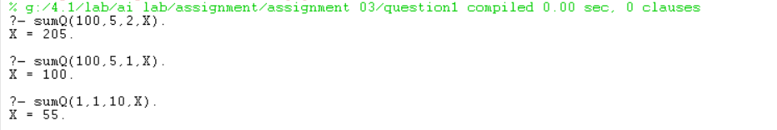

**Code in Python:**

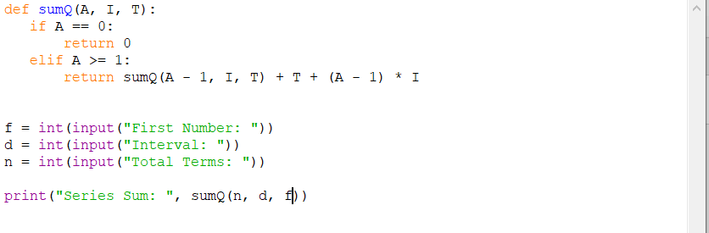

**Output:**

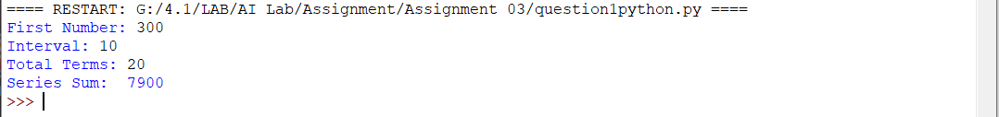

**QUESTION 02:** Define a recursive procedure in Python and in Prolog to find the length of path between two vertices of a directed weighted graph.

**Prolog Code:**

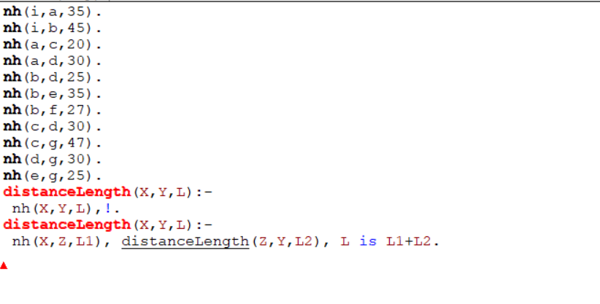

**Output:**

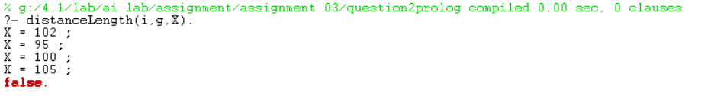

**Python Code:**

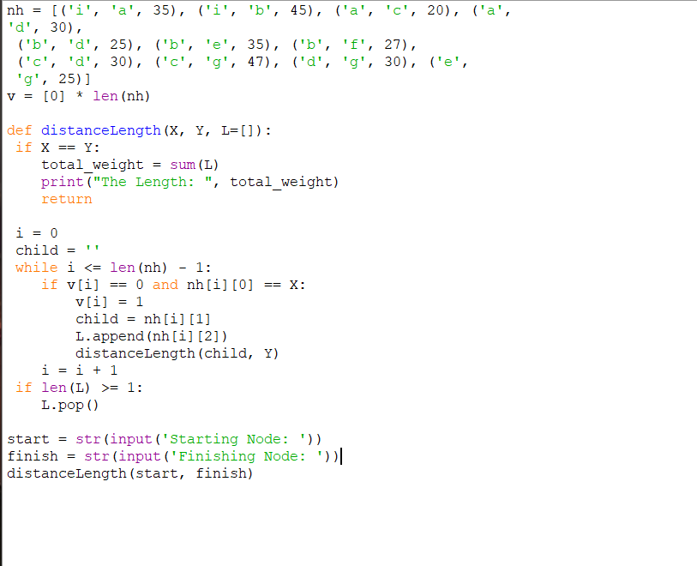

**Output**

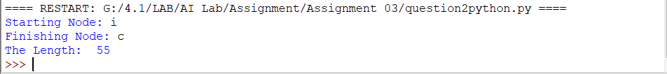

**QUESTION 03:** Write the Python and Prolog codes to find discussed h2.

**Prolog Code:**

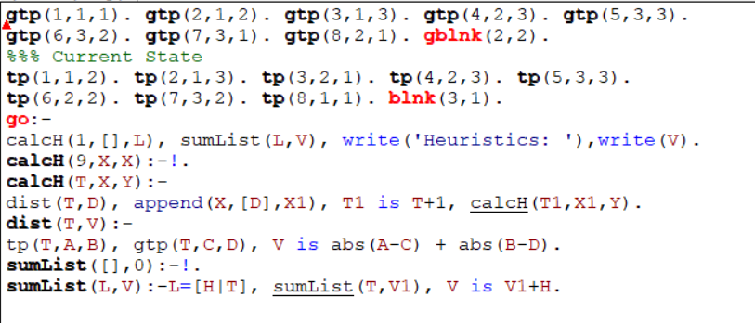

**Output:**



**Python Code**

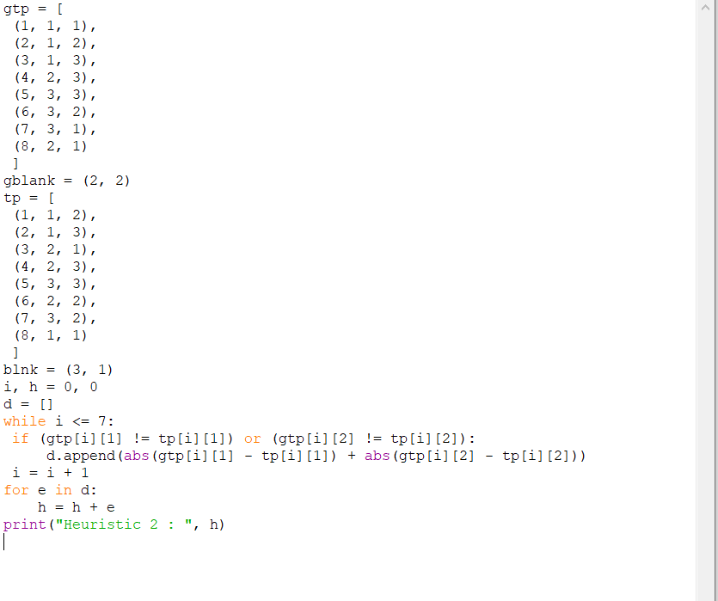

**Output:**



**Question 4:** Write the Python code to find discussed h3.

**Python Code:**

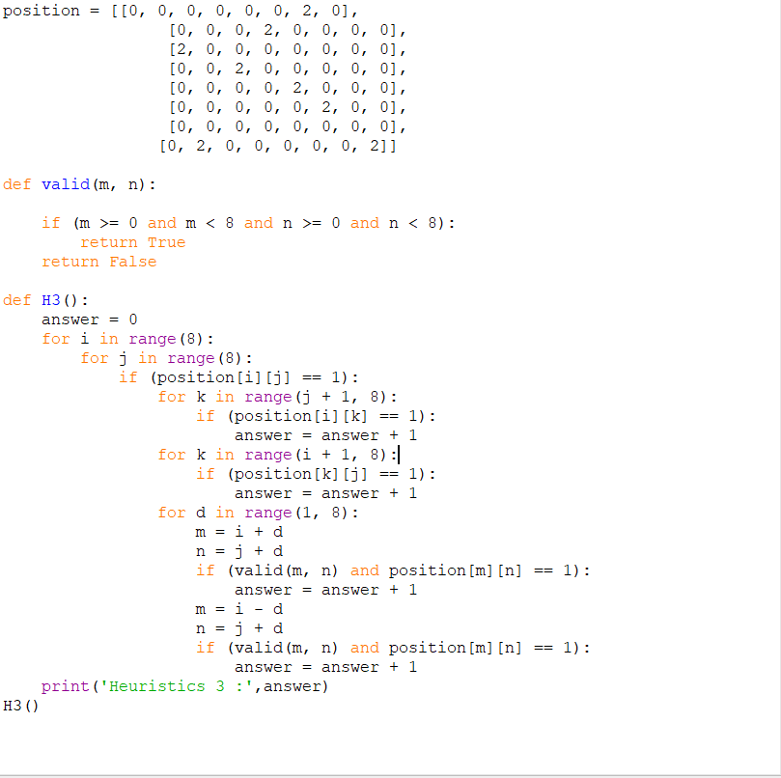

**Output:**

